Name: Megha Krishnamurthy

Student ID: 800974844

Mail-id: mkrish12@uncc.edu

Program Version 1.0 03/12//17

Project Explanation briefly:

This is a java application, which is basically implementation of Dijkstra’s and Breadth first search algorithm.

It also implements minheap () function for the execution of Dijkstra’s algorithm.

Program Implementation:

This Program contains 4 different classes, namely 1.Vertex, 2.Edge, 3.Graph, 4.BinaryHeap, 5.VertexCompare.

**Vertex**: It has all required vertex attributes namely,

1. Name, 2.dist, 3.prev, 4.isUp, 5.adj

**Edge:** Simple class which has primitive attributes 1.edge status and 2.weight.

**Graph**: This has the complete implementation of the algorithm.

1. It has the main method which read the input network file and creates a graph.

2. By reading the queries.txt file, it retrieves all the queries, execute it and output will be redirected to output.txt file.

3. It has functionalities namely, addedge(), changeedge(), shortestpath(), printpath(), rechable()

4. File operations are also done in this class

**MinHeap**: Class having, minheap() implementation.

Program Execution from command prompt:

To execute the program, perform the following steps:

1. Make sure that the classpath is set by echoing. It should be pointing to bin.

Compile: **javac Edge.java Vertex.java VertexCompare.java MinHeap.java Graph.java**

2. Don’t execute from the file location directly. i.e go to src directory (above com folder. do pwd and verify).

3) Execute this command to run the program

**java com.java.shortestpath.Graph network.txt queries.txt output.txt**

Sample image is shown below.

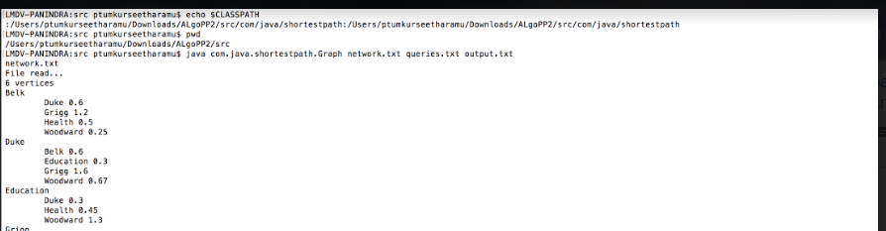

Program Execution from Eclipse IDE:

1. Import the project into eclipse.

2. Perform following steps to add command line args in eclipse:

1. Make sure you have selected the project that you want to execute.

2. Go to "Run" in the main menu and click "RunConfigurations”. Select the arguments tab in the popped up wizard.

3. Give the absolute path/relative path of all the 3 text files (with a space btw each file path) which you wish to supply as arguments.

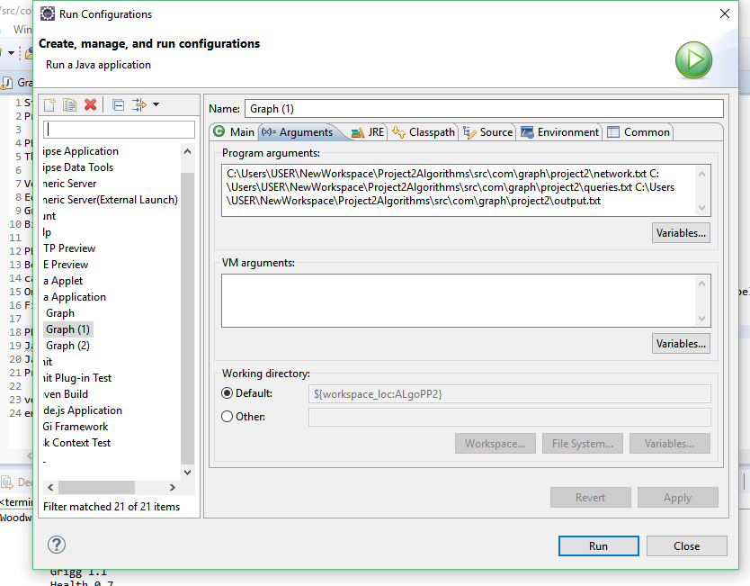

3. Run the Graph.java file by right clicking it.

For any further queries, feel free to contact.

voice: 704-905-2792

email: mkrish12@uncc.edu